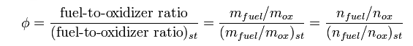

$${2*H}_{2} + O_{2} -> H_{2}O$$

Numerical jacobian

dy/dt = (y(t+delta_t) - y(t))/delta_t

How to do partial derivative numerically?!?!?!?

http://www.math.ohiou.edu/courses/math344/lecture27.pdf